Example 2.1 – Usage of String

using System;

namespace StringExample
{
class Program
{
public static int Main(string[] args)
{
string s1 = "a string";
string s2 = s1;
Console.WriteLine("s1 is " + s1);
Console.WriteLine("s2 is " + s2);
s1 = "another String";
Console.WriteLine("s1 is " + s1);
Console.WriteLine("s2 is " + s2);
Console.ReadLine();
return 0;

}
}
}

Example 2.2 – Usage of if Condition

using System;

namespace MainEntryPoint
{
class Program
{
static void Main(string[] args)
{
Console.WriteLine("Type in a String");
string input;
input = Console.ReadLine();
if (input =="")
{
Console.WriteLine("You typed in an empty string");
}
else if(input.Length < 5)
{
Console.WriteLine("The String had less that 5 characters");
}
else if(input.Length < 10)
{
Console.WriteLine("The String had at least 5 but less that 10 Characters");
}
Console.WriteLine("The String was " + input);
Console.ReadLine();
}
}
}

Example 2.3 Switch Example
using System;
namespace SwitchExample
{
class Program
{
static void Main(string[] args)
{
Console.WriteLine("Type in a String");
string country;
country = Console.ReadLine();
switch(country)
{
case "America":
Console.WriteLine("You have given the input as America");
break;
case "Oman":
Console.WriteLine("You have given the input as Oman");
break;
default:
Console.WriteLine("You have not given any input");
break;
}
Console.ReadLine();
}
}
}

Example 2.5 Nested For

using System;

namespace NestedFor
{
class Program
{
static void Main(string[] args)
{
for(int i = 0; i <100; i+=10)
{
for(int j = i; j < i+10; j++)
{
Console.Write(" " + j);
}
Console.WriteLine();
}
Console.Read();
}
}
}

Example 2.6 While Loop Example

using System;

namespace WhileLoop
{
class Program
{
static void Main(string[] args)

{
int index = 0;
// Continue looping infinitely until internal condition is met.
while (true)
{
int value = ++index;
// Check to see if limit it hit.
if (value > 5)
{
Console.WriteLine("While-loop break");
break;
}
// You can add another condition.
if (value > 100)
{
throw new Exception("Never hit");
}
// Write to the screen on each iteration.
Console.WriteLine("While-loop statement");
}
Console.Read();
}
}
}

Boxing
Implicit conversion of a value type (int, char etc.) to a reference type (object), is known as Boxing. In boxing process, a value type is being allocated on the heap rather than the stack.

Unboxing
Explicit conversion of same reference type (which is being created by boxing process); back to a value type is known as unboxing. In unboxing process, boxed value type is unboxed from the heap and assigned to a value type which is being allocated on the stack.
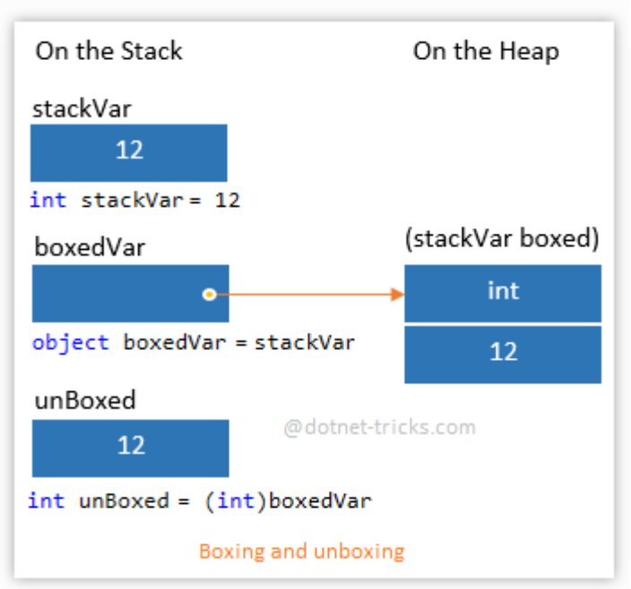
Boxing and Unboxing Example with Forms

namespace BoxExample
{
public partial class Form1 : Form
{
public Form1()
{
InitializeComponent();
}

private void Form1_Load(object sender, EventArgs e)
{

}

private void button1_Click(object sender, EventArgs e)
{
int Val = 1;
Object Obj = Val; //Boxing
int i = (int)Obj; //Unboxing
MessageBox.Show("The value is : " + i);
}
}
}

